**LEBANESE AMERICAN UNIVERSITY**

**USAID – HIGHER EDUCATION SCHOLARSHIP PROGRAM**

**HES - Volunteering Program Verification Form**

This form is to be used to document volunteering hours. If a student volunteers for multiple organizations, a separate form must be used for each organization. **This form must be turned in by the 28th of each month, the latest.**

I certify that the scholar Amal Rajab completed a total of 5 hours of service at InnovaThrive.

The hours were completed hours as per the below:

Hours # 2 (date) _4/11 – 8/11_ (initials of supervisor) __A.K.___

Hours # 1 (date) _11/11 – 15/11_ (initials of supervisor) __A.K.___

Hours # 1 date) _18/11 – 22/11 (initials of supervisor) __A.K.___

Hours # 1 date) _25/11 - 29/11 (initials of supervisor) __A.K.___

Brief description of the activities the scholar performed or participated in:

During the month of November, I focused on researching the application of Artificial Intelligence in language translation. I delved into the specific technologies powering this innovation, such as machine translation and natural language processing. My research explored the advantages, disadvantages, and real-world applications of AI-powered translation tools.

Written feedback about the scholar’s performance:

Amal’s research on artificial intelligence in language translation is both timely and innovative. Her focus on technologies such as machine translation and natural language processing, coupled with an analysis of advantages and disadvantages, showcases her ability to bridge technical and practical applications effectively.

Please rate the overall performance of the scholar at your organization:

|  |  |  |  |
| --- | --- | --- | --- |
|  | Mastery (5) | Proficient (3) | Emerging (1) |
| **Problem solver** | X |  |  |
| **Engaged & Committed** | X |  |  |
| **Open-minded & multicultural** | X |  |  |

Signature

& stamp

__________________________

_

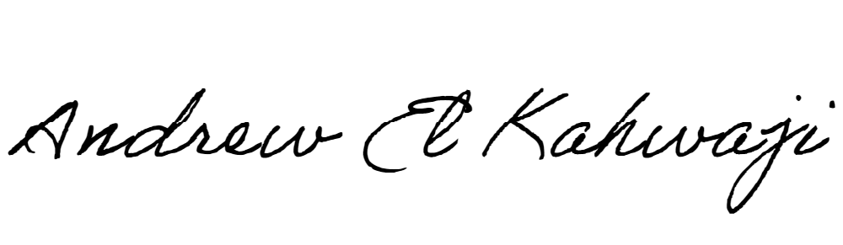

Printed Name _Andrew El Kahwaji_

Date __26/11/2024___

Email __andrew.lifesculptor.coo@gmail.com __

Phone __+961 71 914 378__

**LEBANESE AMERICAN UNIVERSITY**

**USAID – HIGHER EDUCATION SCHOLARSHIP PROGRAM**

